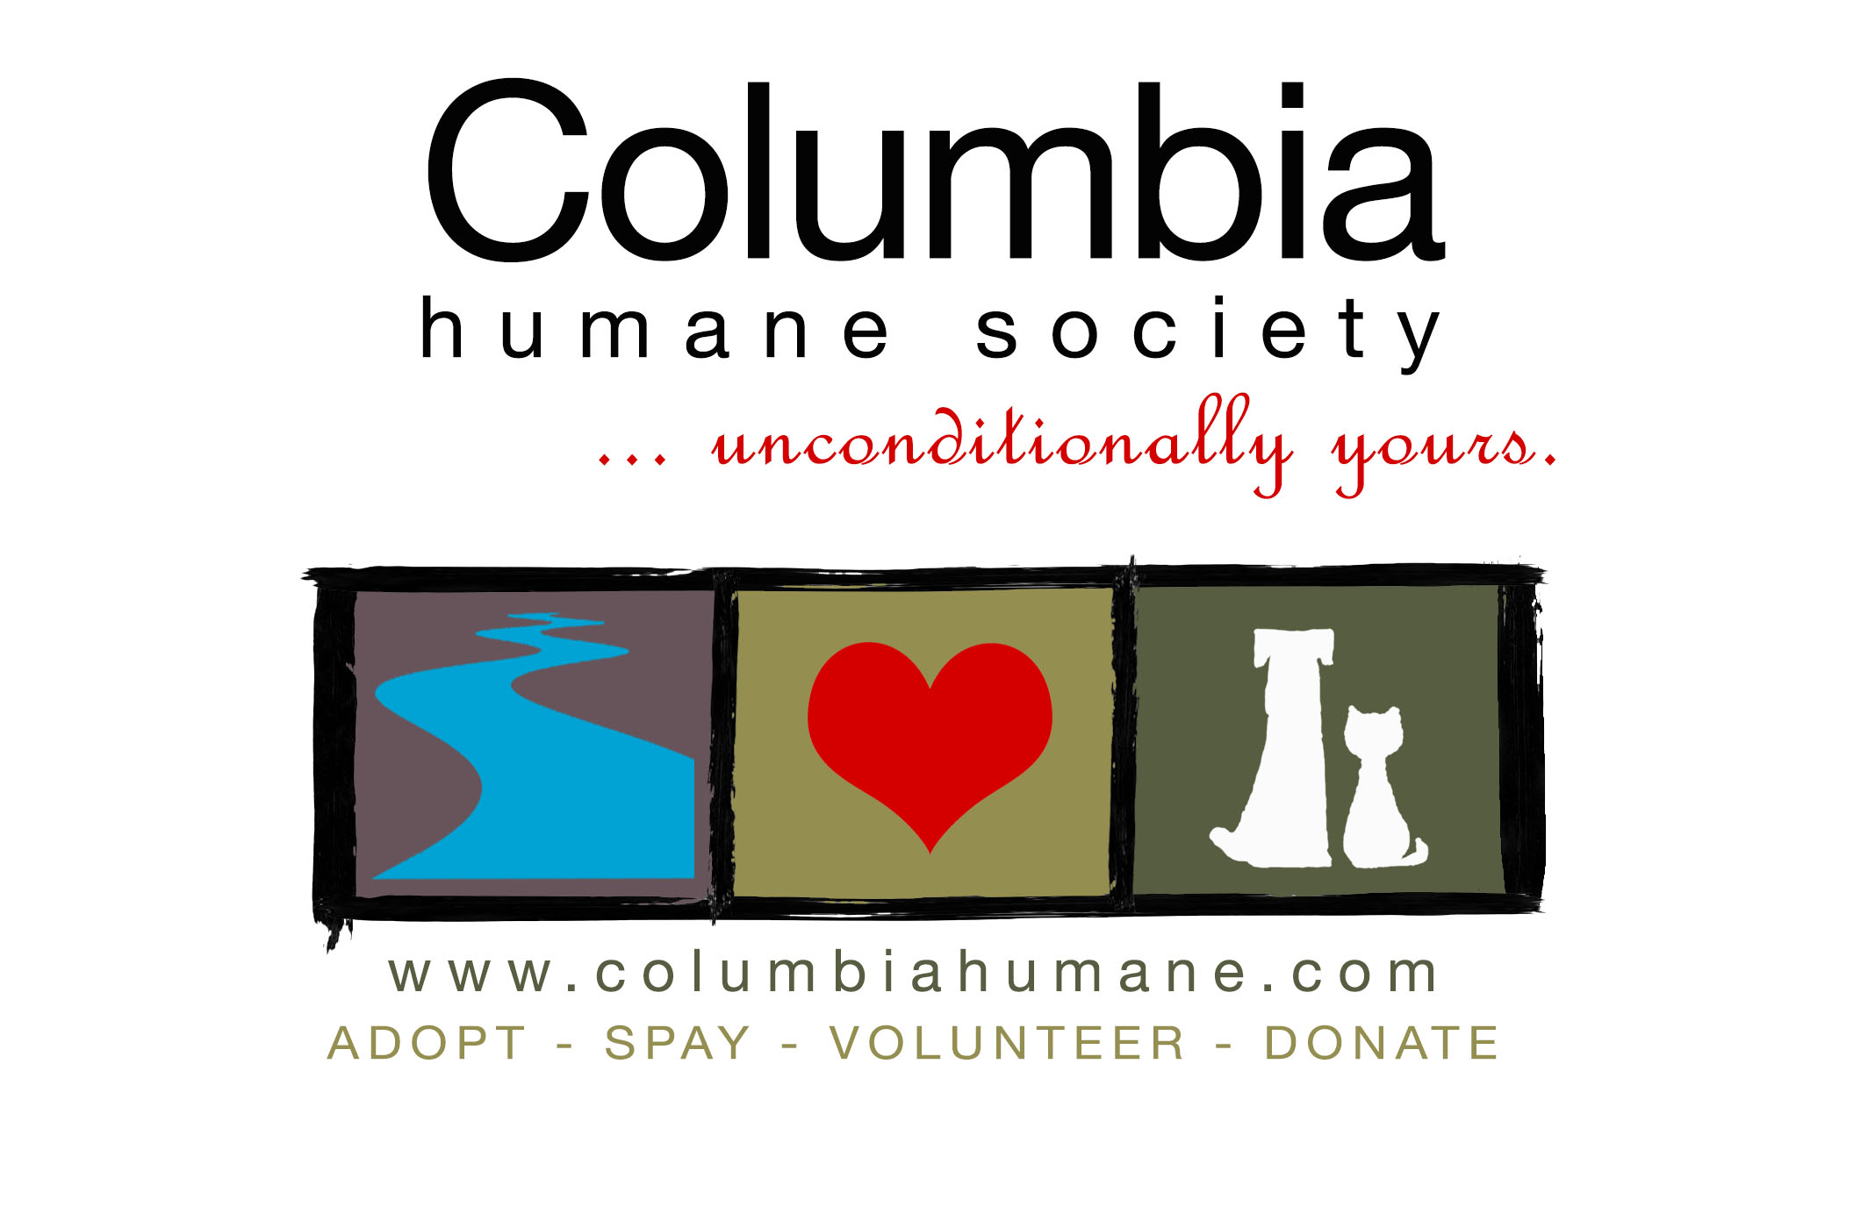
Monday, February 17, 2014
For Immediate Release

The Lick That Saved A Life

(Saint Helens, Oregon): We are blessed to live in Oregon—not just because of the weather, scenery and people. But because a healthy companion animal has not euthanized by an animal shelter nearly any where in this state for the past 12 months. If we’re talking about just Columbia County, that time period extends to eight years. Yes, that’s right. Columbia Humane Society has not put down a animal in eight years for time or space. We are very lucky. Other states can’t say that.

Our southern neighbor is one of those states. California has one of the worst save-rates in the country. Statewide, ½ million animals are put down every year. This is the story about one dog that is getting a second chance…all because of a lick.

Her name is Apple. No one knows where she came from but she somehow found herself in the Baldwin Park Shelter, one of the six Los Angeles County Shelters. These shelters have time and space limits. Apple was given 30 days to find a home. If she were still at the shelter on the 31st day, she would be put down; and that’s where Apple found herself.

She was led into The Room on her 31st day; no living dog ever comes out of The Room. The vet tech administered a sedative to Apple to calm her down so that she wouldn’t resist the next step (the final shot). While the tech was waiting for the sedative to take affect, Apple decided that she really liked this person. So she got off the table, walked over to the tech and licked her hand. She then climbed into her lap, flashed a big smile and gave her a giant lick on the face.

The woman was overcome with emotion and couldn’t find it in her heart to give Apple the fatal shot. Instead she sent out an urgent request for a rescue; a request CHS immediately answered with a resounding yes. Our partner organization, The Jason Debus Heigl Foundation, which is located in Los Angeles, has pulled Apple from the Baldwin Park Shelter on our behalf. They are using their own funds to send Apple to us because they know we have the ability to care for her until we can find her a good home. It won’t be easy, finding a forever home for a solid black pit bull never is, but we have faith in our community of dog lovers.

If you or someone you know is interested in adopting Apple please contact the shelter. She is expected to arrive in Oregon in the coming weeks and she will be available for adoption in March.
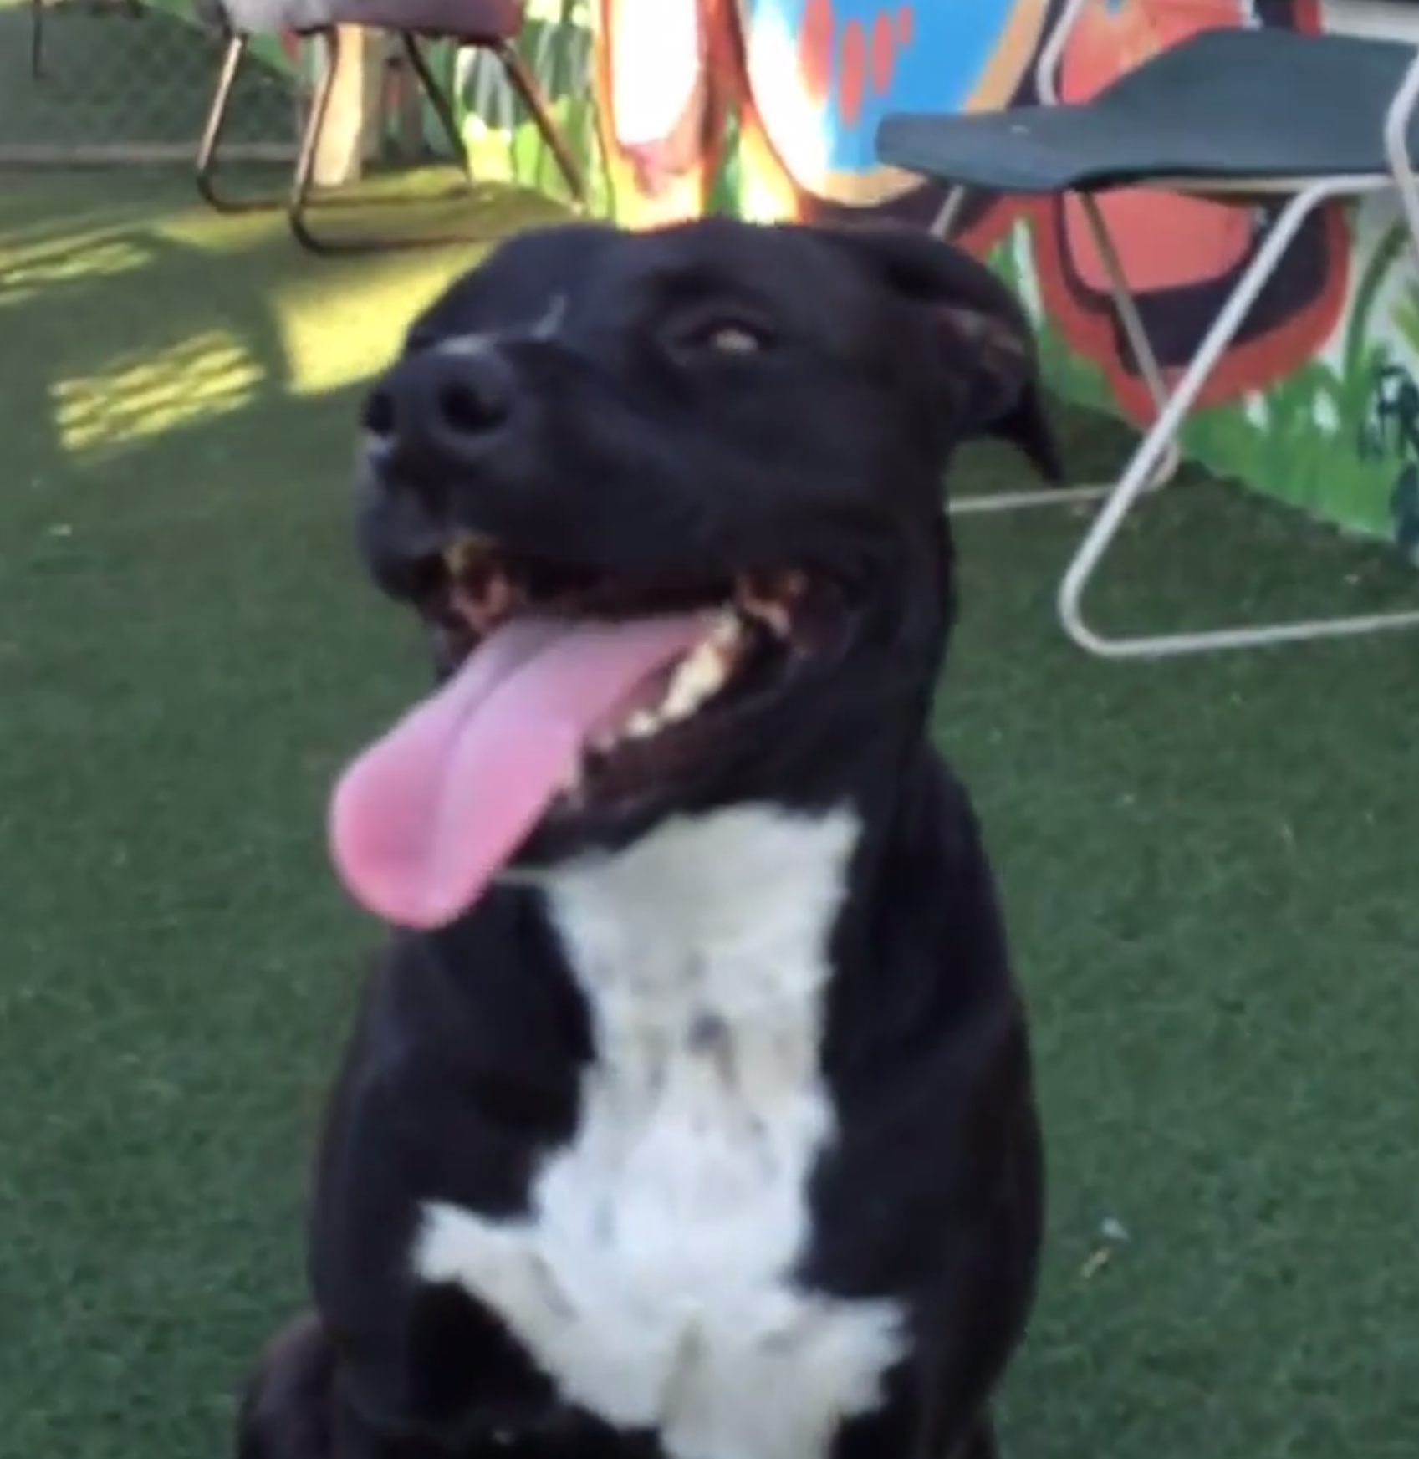

Apple

Press Contact: Melissa Cagle Email: Melissa.Cagle@ColumbiaHumane.org Cell: 678-662-3929
###

